# Fix lỗi IBM_DB_SA trong python

**Cách 1:**

1. Download tại địa chỉ: <https://pypi.org/project/ibm-db-sa/#files>
2. Giải nén tập tin [ibm_db_sa-0.3.5.tar.gz](https://files.pythonhosted.org/packages/a4/7f/8301cafde62a8a86f7ca9b5b64663431900217742b799797739760c5b9ea/ibm_db_sa-0.3.5.tar.gz) bằng winrar hoặc 7-zip
3. Chuyển vào thư mục ibm_db_sa-0.3.5 và chạy lệnh sau để cài đặt

python setup.py install

1. Copy thư mục ibm_db_sa từ đường dẫn **Lib\site-packages\ibm_db_sa-0.3.5-py3.6.egg** (ví dụ: C:\Users\ntd20\AppData\Local\Programs\Python\Python37\Lib\site-packages\ibm_db_sa-0.3.5-py3.7.egg) vào đường dẫn **Lib\site-packages\sqlalchemy\dialects**
2. Chỉnh sửa tập tin _init_.py trong thư mục **Lib\site-packages\sqlalchemy\dialects** như sau:

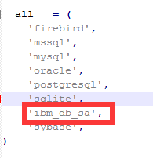

1. Chỉnh sửa tập tin _init_.py trong thư mục **Lib\site-packages\sqlalchemy\databases** như sau:

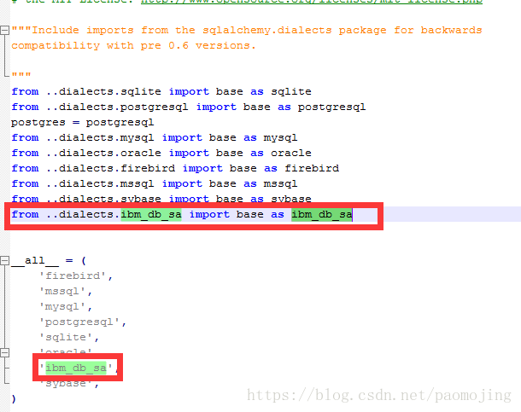

----------------------

**Cách 2:**

1. Cài đặt ibm_db_sa: pip install ibm_db_sa



Đường dẫn sau khi insall: **c:\users\lenovo\anaconda3\envs\pythondata\lib\site-packages**

2. sqlalchemy and ibm_db_sa  
Most of the online use of mysql, there is basically no information about db2, I can only turn over the source code of mysql myself, and found that sqlalchemy can also support db2, but it needs several files in the package to modify:  
**A) Installed ibm_db_sa, when calling, often report error: NoSuchModuleError: Can’t load plugin: sqlalchemy.dialects:ibm_db_sa**  
  
Solution:  
The first step: This is because the installed ibm_db_sa is installed in the site-packages directory by default, but it is not in sqlalchemy. You need to copy the entire directory of ibm_db_sa to site-packages\sqlalchemy\ under dialects  
Step 2: Modify the site-packages\sqlalchemy\dialects under**_init_.py**,as follows:

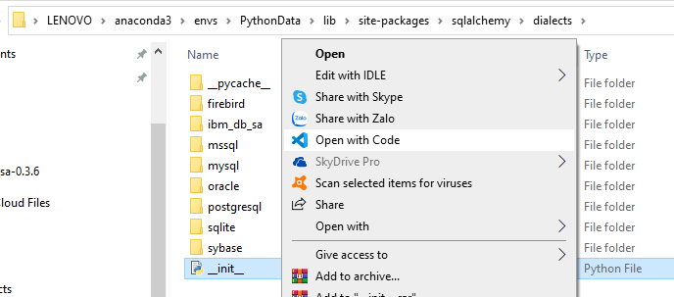  


Step 3: Modify the following under site-packages\sqlalchemy\databases**_init_.py**,as follows:

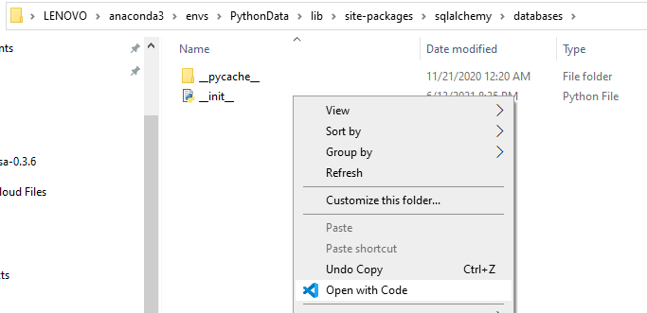  
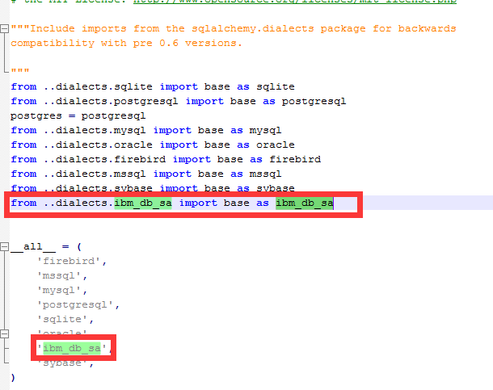  
B) After the above is completed, you can use sqlalchemy and ibm_db_sa to process db2  
